FULL NAME: MPHAHLELE LEBOGANG CYNTHIA
STUDENT NUMBER: 10513869
MODULE CODE: WEDE5120
GROUP: 02
PROPOSAL 02

1 INTRODUCTION
KFC is one of the most famous fast-food chains in the world, known for its original recipe fried chicken. This proposal aims to develop a website that allows customers to view the menu, check special promotions, find store locations and make enquiries easily. The goal is to improve customer service and provide an online presence that is fast, friendly, and easy to use.

2 Brief History
KFC was founded by Colonel Harland Sanders in 1952 in Corbin, Kentucky, USA. The company grew rapidly because of its secret recipe of 11 herbs and spices. Today, KFC operates in thousands of locations worldwide, including many stores across South Africa. It remains the most trusted brand for delicious and affordable meals.

3 Mission and Vision

Mission:
“To sell food in a fast, friendly environment that appeals to price-conscious and health-minded customers.”

Vision:
“To be the world’s most loved and trusted chicken restaurant brand.”

Target Audience:
- Everyone who wants good quality food at reasonable prices
- Teenagers, young adults, families, students, and busy professionals

4 The website aims to:
- Enable delivery and pickup options for meals
- Promote the brand and menu offerings
- Display current promotions and deals to encourage sales
- Help customers find nearby KFC locations using a store location
- Offer a mobile-friendly experience for users on smartphones
- Improve customer engagement and strengthen the KFC brand online

KPIs
Increase Online Orders | Number of orders placed, average order value, repeat orders
Increase Traffic | Total and unique visitors, session duration
Generate Engagement | Newsletter sign-ups, account registration
Provide Information | Page views, time spent on page, effective navigation
Promote Deals | Click-through rates on special offers
Customer Satisfaction | Positive user experience and feedback

5 Key Pages and Features

1) Homepage
- Welcome banner, promotional images, quick navigation, history, mission and vision

2) Menu
- Categories of food items, images, descriptions and prices

3) Promotions
- Display of current special deals and limited-time offers

4) Location
- Google Map integration, store address, and operating hours
5) Contact Us
- Contact details, telephone numbers, email address, and social medial links

6) Enquiries
- Online form for customers to send messages and feedback

6 Technical Requirements

Programming Language and Framework
- Front-End: HTML, CSS, and JavaScript only
- Editor: Visual Studio Code
- Compatibility: Works on all major web
- Responsiveness: Mobile-friendly layout that adapts to different screen sizes

Additional Requirements
- Easy navigation structure
- Fast loading pages
- Clear file organization

WIREFRAME
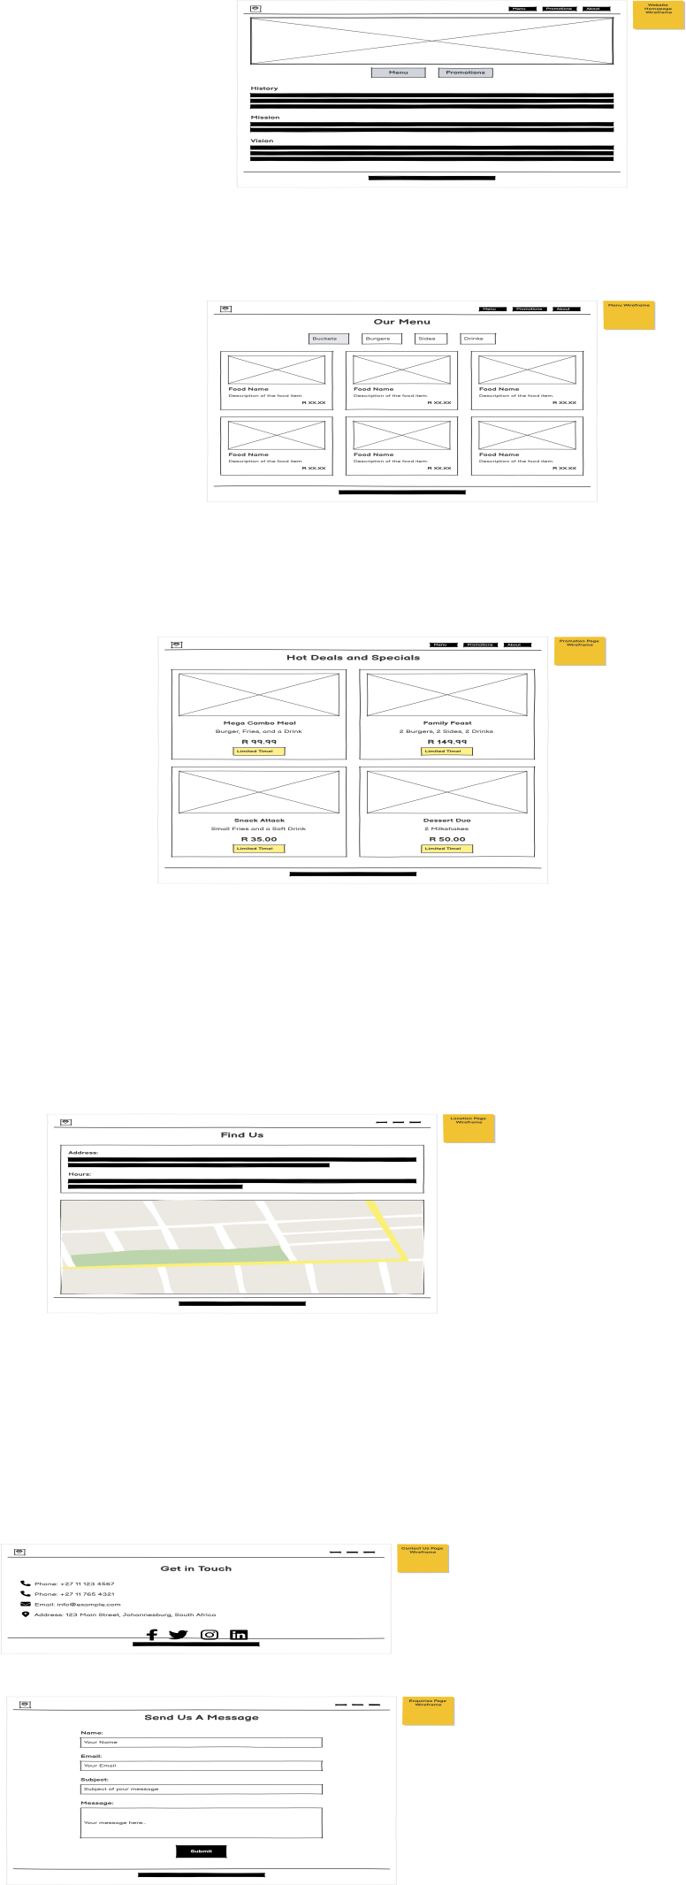

7 Designs and User Experience

Branding and Aesthetic:
Clean, appetizing, and professional design that reflects the KFC identity.
Colour Scheme:
- Red: Primary brand colour for heading
- White: Background for clarity
- Black: For text readability
- Grey: Accent colours

Typography
- Headings: Bold and clear
- Body: Simple sans-serif font, size 14-16px

Layout:
- Grid-based structure
- Card-style designs for menu items
- Responsive for desktop, tablets, and mobile devices

UX Considerations
- Easy navigation with top menu and sticky elements
- Quick access to popular items and deals
- Fast-loading pages, clear feedback on actions

6 Estimated Budget
Category | Cost(ZAR)
Development | R185,000 - R285,000
Hosting and Domain | R42,000 – R84,000 per year
Maintenance and Updates | R108,000 –R 240,000 per year
Total( First Year) | R335,000 –R 609,000
Subsequent years mainly include hosting and maintenance costs (approximately 150,000 – 342,000 per year)

9 Technical Diagram (Simplified)

User Interface
- Front-End: HTML(Structure), CSS (Styling), and JavaScript (Interactivity)

External Integration:
- Google Maps API for location display
- Web Hosting services

Reference:
KFC South Africa. (2026). Official Website. Available at: https://www.kfc.co.za [Accessed: 20 February 2026].
Britannica. (2026). KFC – American restaurant chain. Available at: https://www.brirannica.com [Accessed: 20 February 2026].
Chaffey, D. and Ellis-Chadwick, F. (2019). Digital Marketing: Strategy, Implementation and Practice. 7th ed. Harlow: Pearson Education.
Parmenter, D. (2015). Key Performance Indicators. 1st ed. London: Wiley.
W3Schools. (2026). Web Development Tutorials. Available at; https://www.w3schools.com [Accessed: 10 March 2026].
MDN Web Docs. (2026). HTML, CSS and JavaScript Documentation. Available at: https://developer.mozilla.org [Accessed: 10 March 2026].

